Name:  Teacher : | ____________________________________  ______________________ |  | Date:_________
 | Year 12 Foundation  /22  Finances Test 1  Full working out MUST be shown to get full marks for each question.
Total Time: | 30 minutes
Weighting: | 5%
Equipment: | To be provided by the student: Pen, pencil, ruler, scientific calculator

Steven has a part time job. He works 35 hours a week, and earns $21.50
- Find out how much money Steven earns [2]

- Steven creates a budget and lists his weekly expenditures. Fill in the following totals: [9 marks – ½ each]

 | WEEK 1 | WEEK 2 | WEEK 3 | WEEK 4 | TOTAL
Petrol | $75 | $75 | $75 | $75
Food | $150 | $150 | $150 | $150
Entertainment | $55 | $55 | $55 | $55
Bills | $96.50 | $96.50 | $96.50 | $96.50
Insurances | $66.50 | $45.20 | $66.50 | $45.20
Rent | $175 | $175 | $175 | $175
TOTAL
INCOME:
(Q1 answer)
DIFFERENCE:

- Steven needs to save $2500. How could he do this? [2 marks]


Steven wants to refurnish the games room and he is interested to buy the following:

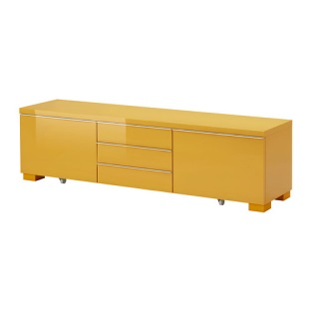


TV $745 X-box $479 TV bench $299 Sofa bed $245

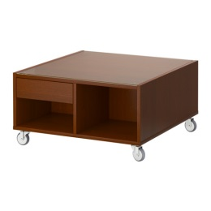


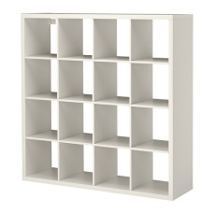

Futon $150 Lamp $56.50 Bookcase $176 Coffee table $129.50

- Calculate the total cost. Show all working using place value, partition or any strategy. [2]

- If Steven saved the $2500, how much change would he receive if any? Show all working or explain your strategy. [4]

END OF ASSESSMENT

Steven has a part time job. He works 35 hours a week, and earns $21.50 per hour.
- Calculate his total income for 1 week.

35 x 21.50 = $752.20
- Total hours
- Mulitplied by Hourly rate
- Total income.

- Steven creates a budget and lists his weekly expenditures. Fill in the following totals: [11 marks – ½ each]
 | WEEK 1 | WEEK 2 | WEEK 3 | WEEK 4 | TOTAL
Petrol | $75 | $75 | $75 | $75 | $300 | 1
Food | $150 | $150 | $150 | $150 | $600 | 1
Entertainment | $55 | $55 | $55 | $55 | $220 | 1
Bills | $96.50 | $96.50 | $96.50 | $96.50 | $386 | 1
Insurances | $66.50 | $45.20 | $66.50 | $45.20 | $223 | 1
Rent | $175 | $175 | $175 | $175 | $700 | 1
total cost | $618.00 | $596.70 | $618.00 | $596.70 | $2,429 | 5
Monthly income | $752.50 | $752.50 | $752.50 | $752.50 | $3,010 | 2(incomes + tot)
Difference | $134.50 | $155.80 | $134.50 | $155.80 | $581 | 6

- Steven needs to save 2500. How could he do this? [2 marks]

Cut down on spending.
Move cheaper rent
Don’t eat meat


Steven wants to refurnish the games room and he is interested to buy the following:




TV $745 X-box $479 TV bench $299 Sofa bed $245






Futon $150 Lamp $56.50 Bookcase $176 Coffee table $129.50

- Calculate the total cost. Show all working using place value, partition or any strategy. [2]

745 + 479 + 299 + 245 + 150 + 56.50 + 176 + 129.50 = $2,289
- Adds all numbers
- Get correct answer

- If Steven saved the $2500, how much change would he receive if any? Show all working or explain your strategy. [4]

2500 – 2289 = $211 change

STRAT: I used the calculator, and subtracted the cost of the furniture from the 2500 he had.

- Subtract
- Correct integers
- Correct answer
- Strategy used is listed

END OF ASSESSMENT

